Neil Barot

Jacob Pinksa

Jared Pinksa

Anthony Ngo

Jalal Omer, Ph.D

11/13/2022

Phase 3 Submission

**Functional Dependencies in 3NF**

Customer

CID -> Name, Age

Printer

PID -> Availability, Fila Type, FilaAmount

Supplier

Product -> Price

Report

ReportID -> Report Date

Employee

EID -> Name

SID2 -> StartDate, EndDate, StartTime, EndTime

**SQL Code for Creation, Population, Views and Queries**

CREATE TABLE Customer (

CID INT NOT NULL,

Name Varchar(30) NOT NULL,

Age INT NOT NULL,

Primary Key(CID),

CHECK (Age >= 18)

);

CREATE TABLE Supplier (

SID INT NOT NULL,

Product varchar(30) NOT NULL,

Price DOUBLE NOT NULL,

Primary Key(SID)

);

CREATE TABLE Schedules (

SID2 INT NOT NULL,

CID INT,

StartDate Varchar(10) NOT NULL,

EndDate Varchar(10) NOT NULL,

StartTime Varchar(6) NOT NULL,

EndTime Varchar(6) NOT NULL,

Primary Key(SID2),

Foreign Key(CID) References Customer(CID)

ON DELETE cascade ON UPDATE cascade,

CHECK(StartDate < EndDate OR (StartDate = EndDate AND StartTime <= EndTime))

);

CREATE TABLE Printer (

PID INT NOT NULL,

SID INT NOT NULL,

FilamentAmt DOUBLE NOT NULL Default(0),

Filament varchar(30) NOT NULL Default("PLA"),

Primary Key(PID),

Foreign Key(SID) References Supplier(SID)

ON DELETE cascade ON UPDATE cascade

);

CREATE TABLE Employee (

EID INT NOT NULL,

Name varchar(30) NOT NULL,

Primary Key(EID)

);

CREATE TABLE Report (

RID INT NOT NULL,

EID INT NOT NULL,

SID INT NOT NULL,

ReportDate Varchar(10) NOT NULL,

History DOUBLE NOT NULL,

Transaction INT,

Primary Key(RID),

Foreign Key(EID) References Employee(EID)

ON DELETE cascade ON UPDATE cascade,

Foreign Key(SID) References Supplier(SID)

ON DELETE cascade ON UPDATE cascade

);

CREATE TABLE Reserves (

SID2 INT,

CID INT,

PID INT,

Primary Key(SID2, CID, PID),

Foreign Key(SID2) References Schedules(SID2)

ON DELETE cascade ON UPDATE cascade,

Foreign Key(CID) References Customer(CID)

ON DELETE cascade ON UPDATE cascade,

Foreign Key(PID) References Printer(PID)

ON DELETE cascade ON UPDATE cascade

);

INSERT INTO Customer (CID, Name, Age)

VALUES (1, "James R. Hill", 21);

INSERT INTO Customer (CID, Name, Age)

VALUES (2, "Enrique M. Brown", 35);

INSERT INTO Customer (CID, Name, Age)

VALUES (3, "Lonnie K. Timmons", 19);

INSERT INTO Customer (CID, Name, Age)

VALUES (4, "Paul M. Numbers", 34);

INSERT INTO Customer (CID, Name, Age)

VALUES (5, "Dennis L. Villanueva", 23);

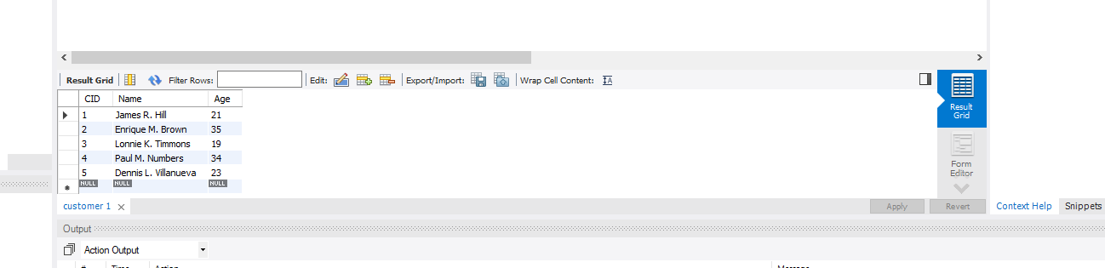

INSERT INTO Supplier (SID, Product, Price)

VALUES (1, "PLA", 15.19);

INSERT INTO Supplier (SID, Product, Price)

VALUES (2, "PLA", 21.00);

INSERT INTO Supplier (SID, Product, Price)

VALUES (3, "PETG", 27.00);

INSERT INTO Supplier (SID, Product, Price)

VALUES (4, "PETG", 18.99);

INSERT INTO Supplier (SID, Product, Price)

VALUES (5, "PETG", 19.99);

INSERT INTO Supplier (SID, Product, Price)

VALUES (6, "ABS", 32.00);

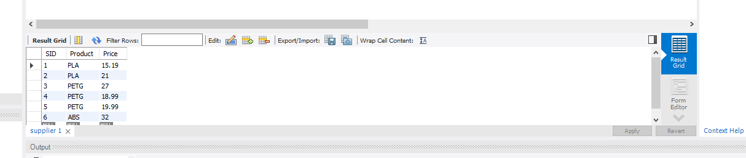

INSERT INTO Schedules (SID2, CID, StartDate, EndDate, StartTime, EndTime)

VALUES (1, 3, "11/17/2022", "11/17/2022", "11:30", "16:30");

INSERT INTO Schedules (SID2, CID, StartDate, EndDate, StartTime, EndTime)

VALUES (2, 5, "11/22/2022", "11/23/2022", "14:30", "12:00");

INSERT INTO Schedules (SID2, CID, StartDate, EndDate, StartTime, EndTime)

VALUES (3, 1, "11/18/2022", "11/19/2022", "10:00", "11:00");

INSERT INTO Schedules (SID2, CID, StartDate, EndDate, StartTime, EndTime)

VALUES (4, 2, "11/24/2022", "11/26/2022", "13:00", "11:00");

INSERT INTO Schedules (SID2, CID, StartDate, EndDate, StartTime, EndTime)

VALUES (5, 4, "11/14/2022", "11/15/2022", "9:30", "12:00");

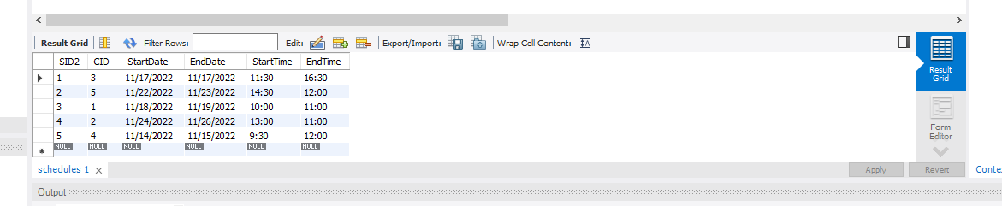

INSERT INTO Printer (PID, SID, FilamentAmt, Filament)

VALUES (1, 6, 1, "PLA");

INSERT INTO Printer (PID, SID, FilamentAmt, Filament)

VALUES (2, 5, 0.7, "PTEG");

INSERT INTO Printer (PID, SID, FilamentAmt, Filament)

VALUES (3, 4, 0.5, "TPE");

INSERT INTO Printer (PID, SID, FilamentAmt, Filament)

VALUES (4, 3, 0.9, "ABS");

INSERT INTO Printer (PID, SID, FilamentAmt, Filament)

VALUES (5, 2, 0.2, "ASA");

INSERT INTO Printer (PID, SID, FilamentAmt, Filament)

VALUES (6, 1, 1, "PA");

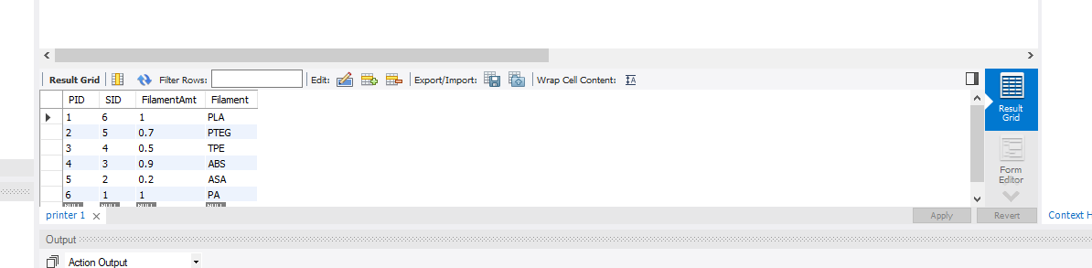

INSERT INTO Employee (EID, Name)

VALUES (1, "Marie T. Hayes");

INSERT INTO Employee (EID, Name)

VALUES (2, "Michael B. Stafford");

INSERT INTO Employee (EID, Name)

VALUES (3, "Wendell M. Rosario");

INSERT INTO Employee (EID, Name)

VALUES (4, "Raymond A. Wilcox");

INSERT INTO Employee (EID, Name)

VALUES (5, "John R. Olvera");

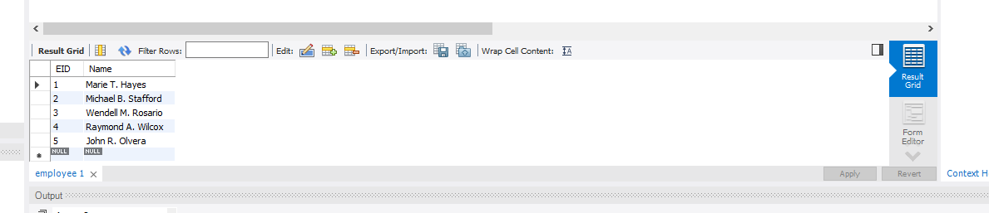

INSERT INTO Report (RID, EID, ReportDate, Transaction, History, SID)

VALUES (4, 1, "11/01/2022", 10, 0.75, 4);

INSERT INTO Report (RID, EID, ReportDate, Transaction, History, SID)

VALUES (3, 2, "11/03/2022", 11, 0.8, 1);

INSERT INTO Report (RID, EID, ReportDate, Transaction, History, SID)

VALUES (5, 3, "10/24/2022", 19, 0.1, 3);

INSERT INTO Report (RID, EID, ReportDate, Transaction, History, SID)

VALUES (1, 4, "11/04/2022", 8, 0.5, 1);

INSERT INTO Report (RID, EID, ReportDate, Transaction, History, SID)

VALUES (6, 5, "10/17/2022", 9, 0.75, 5);

INSERT INTO Report (RID, EID, ReportDate, Transaction, History, SID)

VALUES (2, 3, "10/21/2022", 10, 0.8, 2);

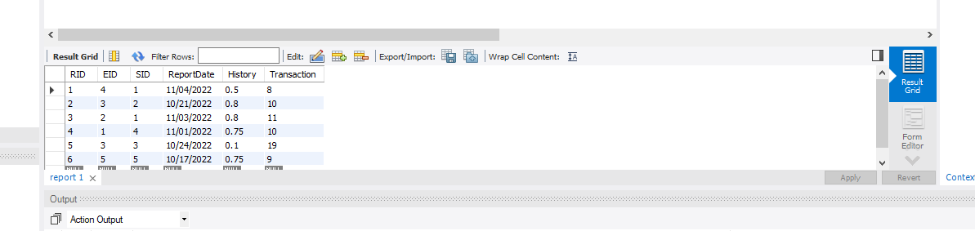

INSERT INTO Reserves (SID2, CID, PID)

VALUES (1, 2, 3);

INSERT INTO Reserves (SID2, CID, PID)

VALUES (2, 1, 2);

INSERT INTO Reserves (SID2, CID, PID)

VALUES (3, 3, 1);

INSERT INTO Reserves (SID2, CID, PID)

VALUES (4, 4, 5);

INSERT INTO Reserves (SID2, CID, PID)

VALUES (5, 5, 4);

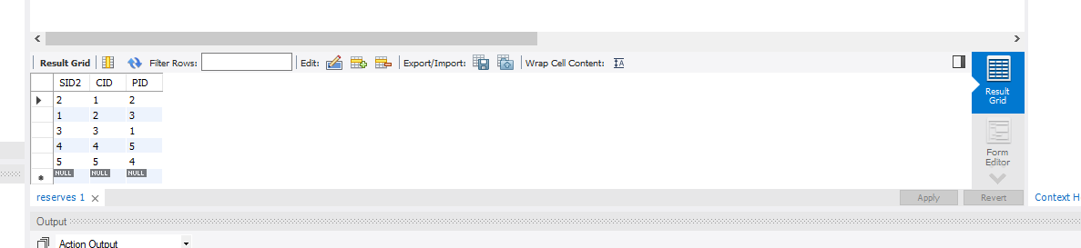

SELECT

PID, Filament, FilamentAmt

FROM

Printer

WHERE

FilamentAmt > 0.5;

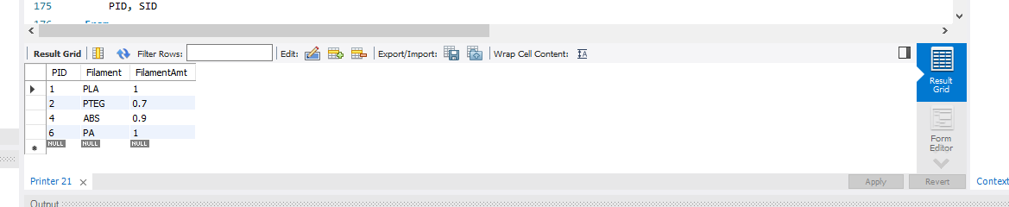

SELECT

SID, Price, Product

FROM

Supplier

ORDER BY

Price;

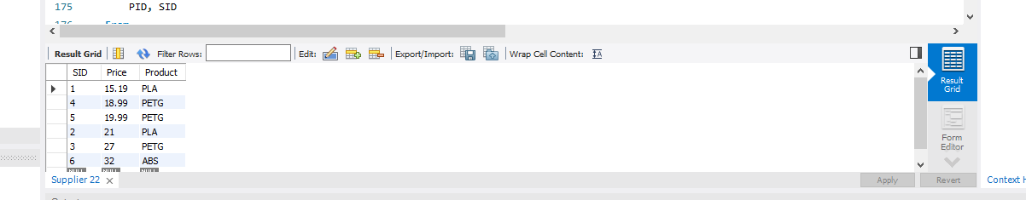

Select

PID, SID

From

Printer

Where

SID <= 3;

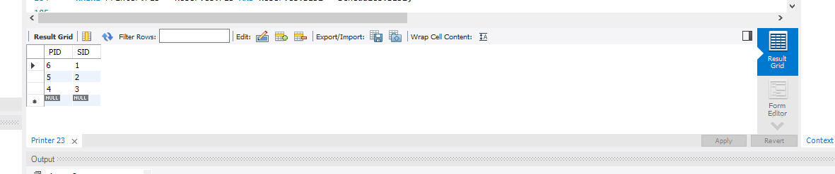

CREATE VIEW list_usage AS

SELECT Printer.PID, Schedules.SID2, StartDate, EndDate, Filament, FilamentAmt

FROM Schedules, Printer, Reserves

WHERE Printer.PID = Reserves.PID AND Reserves.SID2 = Schedules.SID2;

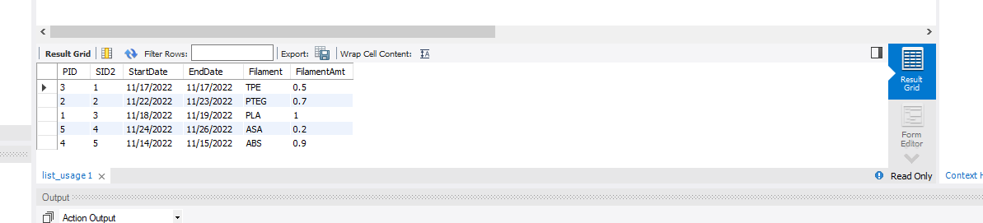

CREATE VIEW accumulated_usage AS

SELECT Reserves.PID, Count(Reserves.CID)

FROM Printer, Customer, Reserves

Where Printer.PID = Reserves.PID AND Customer.CID = Reserves.CID

GROUP BY Reserves.PID;

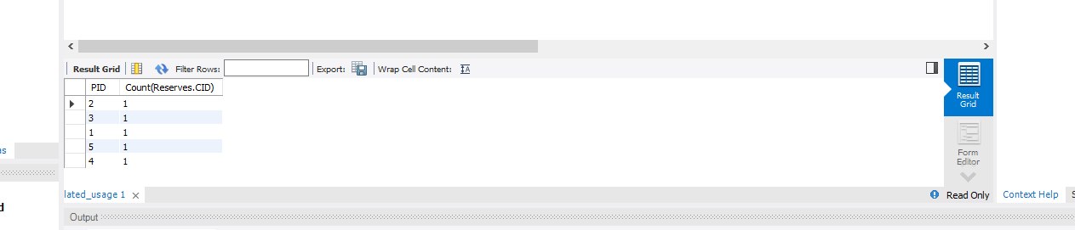

CREATE VIEW Above_avg_price AS

SELECT Product, Price

FROM Supplier

WHERE Price > (SELECT AVG(Price) FROM Supplier)

